## **How Do I Junk My Vehicle?**

## **AFI 31-218**

**3-4.e. (2).** (Added) (35FWSUP) Salvage of Vehicle. Owners must go to an approved salvage yard to retrieve a junk/scrap receipt, front and back license plates, road tax decal, and registration paperwork, and must bring these items to Pass and Registration. Pass and Registration will issue a Japanese POA and 35 FW Form 97EJ to be taken to a local insurance company to acquire a deregistered title certificate. This certificate must be brought back to Pass and Registration within 5 duty days, at this time the vehicle will be removed from DBIDS.

**Step 1**

Take your car to a junkyard.

**Step 2**

Have junkyard give you your license plates, road tax sticker, and a receipt saying that your vehicle is there.

**Step 3**

Bring license plates, road tax sticker, junkyard receipt, and all of your vehicle information (road tax, JCI, insurance, title, etc.) to the Pass and Registration office.

**Step 4**

Pass and Registration will take your road tax sticker and verify junk receipt. Once verified, we will issue you two pieces of paperwork. One is a Japanese Power of Attorney and the other is a 35 FW Form 97EJ. ***We will not be able to deregister your vehicle at this time.***

**Step 5**

Take the Japanese POA, 97EJ and your license plates to your insurance company or the junkyard.

**Step 6**

The insurance company or junkyard will send out for a Junk Title.

**Step 7**

Once you get the Junk Title back, bring it to Pass and Registration. ***Once you bring the Junk Title, we will be able to de-register your vehicle from your name.***

**HACHINOHE Port /LTO OFFICE**

**Hours: 0900-1200 & 1300-1600, MON-FRI,**

**CLOSED JP HOLIDAYS**

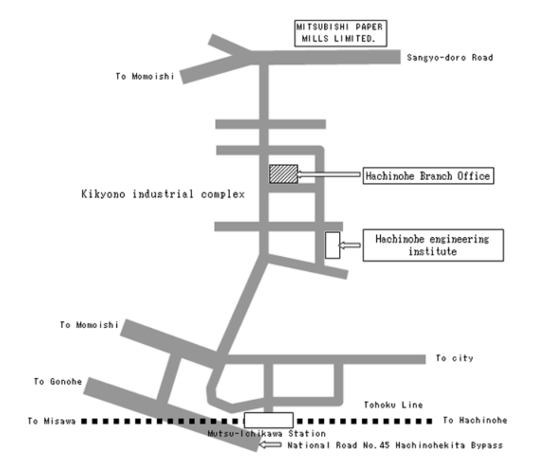

**GPS Coordinates for:**

* **LTO Hachinohe Office: 40.569905, 141.458738**
* **Hachinohe Port: 40.532422, 141.51611**
* **Misawa AB: 40.687244, 141.364732**